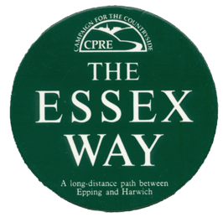

22nd-23rd June 2019
Solstice Weekend
http://www.therobgeorgefoundation.org

The Rob George Foundation £1000 challenge!
Registered Charity No: 1156026

“Rob’s Big Walk 2019”

The Essex Way is a way-marked 82-mile long walk, starting in Epping in the southwest, crossing the Dedham Vale and Constable country, finishing at the port of Harwich on the Stour estuary.

It passes through ancient woodlands, open farmland, tree-lined river valleys and leafy green lanes, unveiling historic towns and villages along the way. Follow the poppies……………..

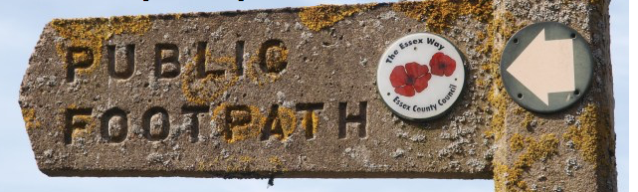

Calling Local Businesses, Groups and Clubs………
Following the route of The Essex Way Relay Race, we have divided the entire 82 mile route into ten bite sized pieces and are looking for teams made up of any number to take on the challenge of walking a section and raising at least £1000 for the Rob George Foundation. There will be a check-in at each start/end point with directions for walkers, emergency supplies and medals for participants!

When?.........
This walking event will take place over the Summer Solstice Weekend of 22nd/23rd June 2019. Walking will take place in daylight hours only. Each team will have an allocated start time and an experienced Rob George Foundation “pace-setter” will lead each team. All walkers will be free to either keep up with the pace (approx. 3 miles/hr) or walk at their own speed – the pace-setters are only there to make sure our Olympic Torch makes it to the next team’s start point on schedule!

Why?.......
The Rob George Foundation exists in memory of Rob, who died aged 21 in 2013, after a battle bravely fought against Leukaemia. Please visit: http://www.therobgeorgefoundation.org for lots of information on the work we do.

We aim:-
- To provide practical and/or financial support to young people with life threatening or terminal illnesses.
- To provide financial support to young people who demonstrate exceptional commitment and/or ability in the worlds of sport or performing arts but may be held back by their financial situation from pursuing their goals.

“Making a Difference –
One Individual at a Time!”

And one more thing…..
Please come and walk with us because you can, and because you owe it to yourself to get up and out and to explore the beautiful Essex countryside on your doorstep! You will be amazed by its variety and splendour. Whether you choose to rise with the mid summer sun or at a more leisurely time, this is your opportunity to mark the summer and achieve something really special in the company of family, friends and colleagues!!

You can choose which section or sections you wish to walk, do as many as you like, simply name your starting point:-

Saturday 22nd June 2019
Stage 1: 5.00am - Epping – Chipping Ongar (7.5 miles)
Stage 2: 7.15am - Chipping Ongar – Good Easter (9.5 miles)
Stage 3: 10.45am - Good Easter – Little Leighs (9.5 miles)
Stage 4: 2.00pm - Little Leighs – Cressing (10.1 miles)
Stage 5: 6.00pm - Cressing – Great Tey (9.4 miles)
(approx. finish 9.30pm)
Sunday 23rd June 2019
Stage 6: 5.00am - Great Tey – West Bergholt (5.7 miles)
Stage 7: 7.00am - West Bergholt – Dedham (11.2 miles)
Stage 8: 11.00am - Dedham – Bradfield (8 miles)
Stage 9: 1.30pm - Bradfield – Ramsay (5.3 miles)
Stage 10: 3.30pm - Ramsay – Harwich Lighthouse (5.5 miles)
(approx. finish 5.30pm)

Sunrise 4:46 - Sunset 21:17

Entry Form
Rob’s Big Walk 2019

Please return this form to mailto:lorraine@therobgeorgefoundation.co.uk

Name of Company/Group/Club: Enter the name of the company/group/club
Lead name of team: Enter the lead name of the team
Tel. Nos. for lead contact: Enter the contact number
Email address for lead contact: Enter the email address
Team Name: Enter the team name
Address of Company/Group/Club: Enter the address
We would like to walk Stage(s) Enter the stage(s) you will be walking
Name/ages of participants (if you know, otherwise can be collected later):
Enter the name and age of participants

Signature of Lead Person: Enter the signature
Date of entry: Enter the date dd/mm/yy

We pledge to attempt to complete Rob’s £1000 challenge. We will attend at our allocated starting place at the correct time and Walk for Rob!

Everyone participating will sign on the day to confirm they are fit to attempt the challenge and do so at their own risk.

Fundraising can take any form and any amount raised to support the work of The Rob George Foundation will be very gratefully received – but we ask you to aim for a minimum of £1000 per team. As a charity run by volunteers, and with next to no overheads, you can relax in the knowledge that just about every penny of what is raised will reach the young people who apply to us for help – a fact we are extremely proud of!! We will supply sponsor forms, assistance in setting up online fundraising pages etc. if required.

Thank you for joining the fun.
Lorraine George (Trustee)
Philip George (Chairman/Trustee)
David Cant (Trustee)
John O’Connor Treasurer/Trustee)
Sam George (Trustee)
Andrew Kennedy (Trustee)

